1. What is SQL? What is DML? What is DDL? Recite the most important SQL commands.
- Structured Query Language
- DML is Data Manipulation Language and consists of the following commands:
SELECT, INSERT, UPDATE, and DELETE (also known as CRUD).
- DDL is Data Definition Language and consists of the following commands:
CREATE, DROP, ALTER, GRANT, REVOKE
It’s used mainly for administration.
2. What is Transact-SQL (T-SQL)?
T-SQL is an extension to the standard SQL language and it features support for writing business logic. You can write procedures, functions. It has exception, conditional statements and loops.
3. Start SQL Management Studio and connect to the database TelerikAcademy. Examine the major tables in the "TelerikAcademy" database.
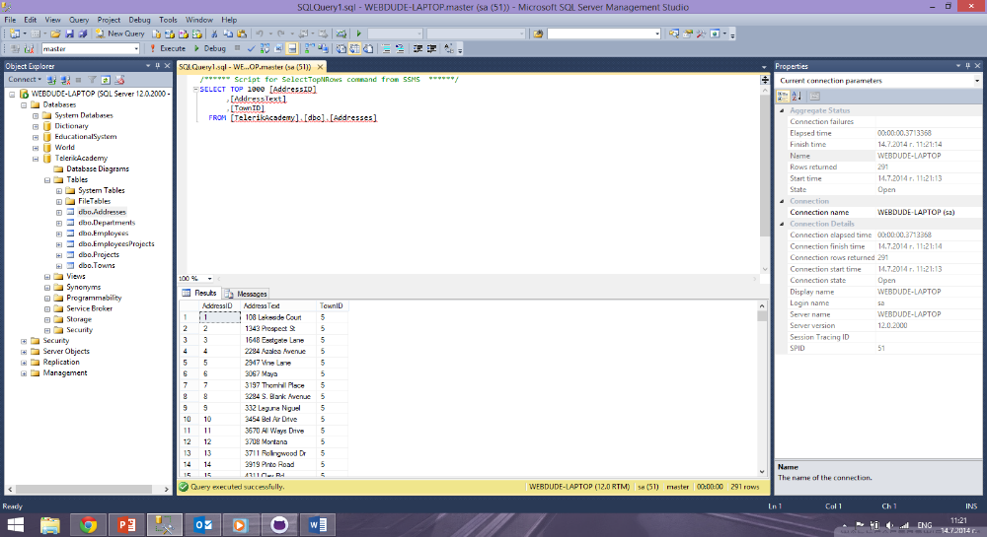
4. Write a SQL query to find all information about all departments (use "TelerikAcademy" database).
USE TelerikAcademy
SELECT * FROM Departments

5. Write a SQL query to find all department names.
USE TelerikAcademy
SELECT Name FROM Departments

6. Write a SQL query to find the salary of each employee.
USE TelerikAcademy
SELECT FirstName + ' ' + LastName AS EmployeeName, Salary FROM Employees

7. Write a SQL to find the full name of each employee.
USE TelerikAcademy
SELECT FirstName + ' ' + LastName AS EmployeeName FROM Employees

8. Write a SQL query to find the email addresses of each employee (by his first and last name). Consider that the mail domain is telerik.com. Emails should look like “John.Doe@telerik.com". The produced column should be named "Full Email Addresses".

USE TelerikAcademy
SELECT FirstName + '.' + LastName + '@telerik.com' AS EmployeeEmails FROM Employees

9. Write a SQL query to find all different employee salaries.
USE TelerikAcademy
SELECT DISTINCT Salary FROM Employees

10. Write a SQL query to find all information about the employees whose job title is “Sales Representative“.
USE TelerikAcademy
SELECT * FROM Employees WHERE JobTitle = 'Sales Representative'

11. Write a SQL query to find the names of all employees whose first name starts with "SA".
USE TelerikAcademy
SELECT FirstName FROM Employees WHERE FirstName LIKE 'SA%'

12. Write a SQL query to find the names of all employees whose last name contains "ei".
USE TelerikAcademy
SELECT LastName FROM Employees WHERE LastName LIKE '%ei%'

13. Write a SQL query to find the salary of all employees whose salary is in the range [20000…30000].
USE TelerikAcademy
SELECT Salary FROM Employees WHERE Salary > 20000 AND Salary < 30000

14. Write a SQL query to find the names of all employees whose salary is 25000, 14000, 12500 or 23600.
USE TelerikAcademy
SELECT FirstName, LastName, Salary FROM Employees WHERE Salary in (12500, 14000, 23600, 25000)
order by Salary

15. Write a SQL query to find all employees that do not have manager.
USE TelerikAcademy
SELECT * FROM Employees WHERE ManagerID IS NULL

16. Write a SQL query to find all employees that have salary more than 50000. Order them in decreasing order by salary.
USE TelerikAcademy
SELECT FirstName, LastName, Salary FROM Employees WHERE Salary > 50000
order by Salary desc

17. Write a SQL query to find the top 5 best paid employees.
USE TelerikAcademy
SELECT TOP 5 FirstName, LastName, Salary FROM Employees
order by Salary desc

18. Write a SQL query to find all employees along with their address. Use inner join with ON clause.
USE TelerikAcademy
SELECT e.EmployeeID, e.FirstName, e.LastName, a.AddressText
FROM Employees AS e JOIN Addresses AS a ON e.AddressID = a.AddressID

19. Write a SQL query to find all employees and their address. Use equijoins (conditions in the WHERE clause).
USE TelerikAcademy
SELECT e.EmployeeID, e.FirstName, e.LastName, a.AddressText
FROM Employees AS e, Addresses AS a
WHERE e.AddressID = a.AddressID

20. Write a SQL query to find all employees along with their manager.
USE TelerikAcademy
SELECT e.FirstName + ' ' + e.LastName AS Employee,
m.FirstName + ' ' + m.LastName AS Manager
FROM Employees e JOIN Employees m
ON e.ManagerID = m.EmployeeID

21. Write a SQL query to find all employees, along with their manager and their address. Join the 3 tables: Employees e, Employees m and Addresses a.
USE TelerikAcademy
SELECT e.FirstName + ' ' + e.LastName AS Employee,
m.FirstName + ' ' + m.LastName AS Manager,
a.AddressText AS EmployeesAddress
FROM Employees e JOIN Employees m
ON e.ManagerID = m.EmployeeID
JOIN Addresses a
ON a.AddressID = a.AddressID

22. Write a SQL query to find all departments and all town names as a single list. Use UNION.
USE TelerikAcademy
SELECT Name FROM Departments
UNION
SELECT Name FROM Towns

23. Write a SQL query to find all the employees and the manager for each of them along with the employees that do not have manager. Use right outer join. Rewrite the query to use left outer join.
USE TelerikAcademy
SELECT e.FirstName, e.LastName, m.FirstName + ' ' + m.LastName AS Manager
FROM Employees e left join Employees m ON e.ManagerID = m.EmployeeID

USE TelerikAcademy
select e.FirstName, e.LastName, m.FirstName + ' ' + m.LastName as Manager
from Employees e
full outer join Employees m ON e.ManagerID = m.EmployeeID order by Manager

24. Write a SQL query to find the names of all employees from the departments "Sales" and "Finance" whose hire year is between 1995 and 2005.
USE TelerikAcademy
SELECT e.FirstName, e.LastName, e.HireDate FROM Employees e join Departments d
ON e.DepartmentID = d.DepartmentID WHERE d.Name in('Sales','Finance') and
e.HireDate >= '1995-01-01 00:00:00' and e.HireDate <= '2005-12-31 23:59:59' order by HireDate

